**Python – Volume of a Solid**

You will be given a mathematical formula used for calculating the volume of a random geometric solid. Write a program that will accept input from the user for the necessary measurements and then calculate the volume for the user. If your formula contains pi, use the constant built into the Python math class.

Be sure to make your program user friendly. Print a small introduction to explain what the program does before asking the user for the appropriate values. Be sure to print the results using a full sentence and proper labeling of the results.

Also remember to use commenting and white space to make your code readable. Your name, email should be included in the comments at the top of your code. (Look up the standard way to do that in Python.)

You will be scored using the following:

Prints opening instructions for users _____/3

In a user-friendly format

Prompts users for necessary values _____/3

Calculates the correct results _____/3

Prints the results using full sentences, labels, _____/3

and user-friendly formatting.

Proper commenting and whitespace in code _____/3

**Total _____/15**

**1) Volume of a Sphere**

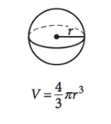

* r is the radius of the sphere.

**2) Volume of a Cone**

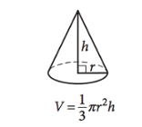

* r is the radius of the circular side of the cone.
* h is the height of the pointed part of the cone (as measured from the center of the circular part of the cone).

**3) Volume of a Pyramid**

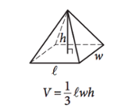

l is the length of one of the edges of the rectangular part of the pyramid.

* h is the height of the figure at its peak (as measured from the center of the rectangular part of the pyramid).
* w is the width of one of the edges of the rectangular part of the pyramid